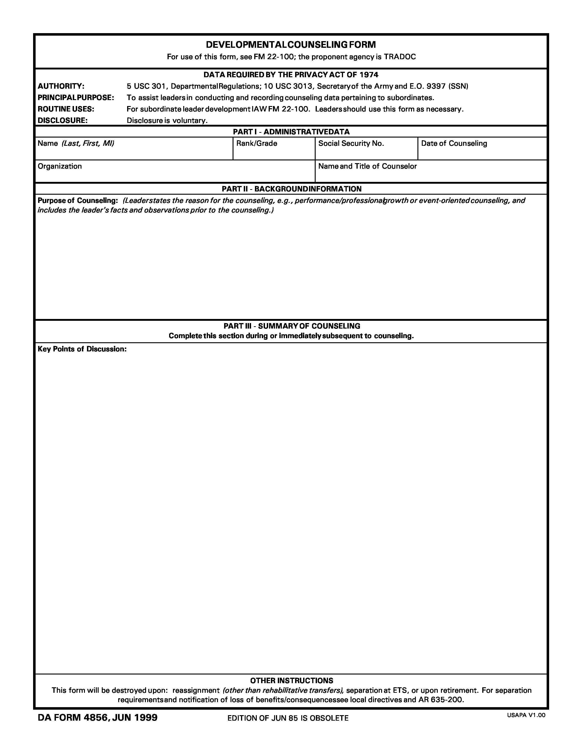
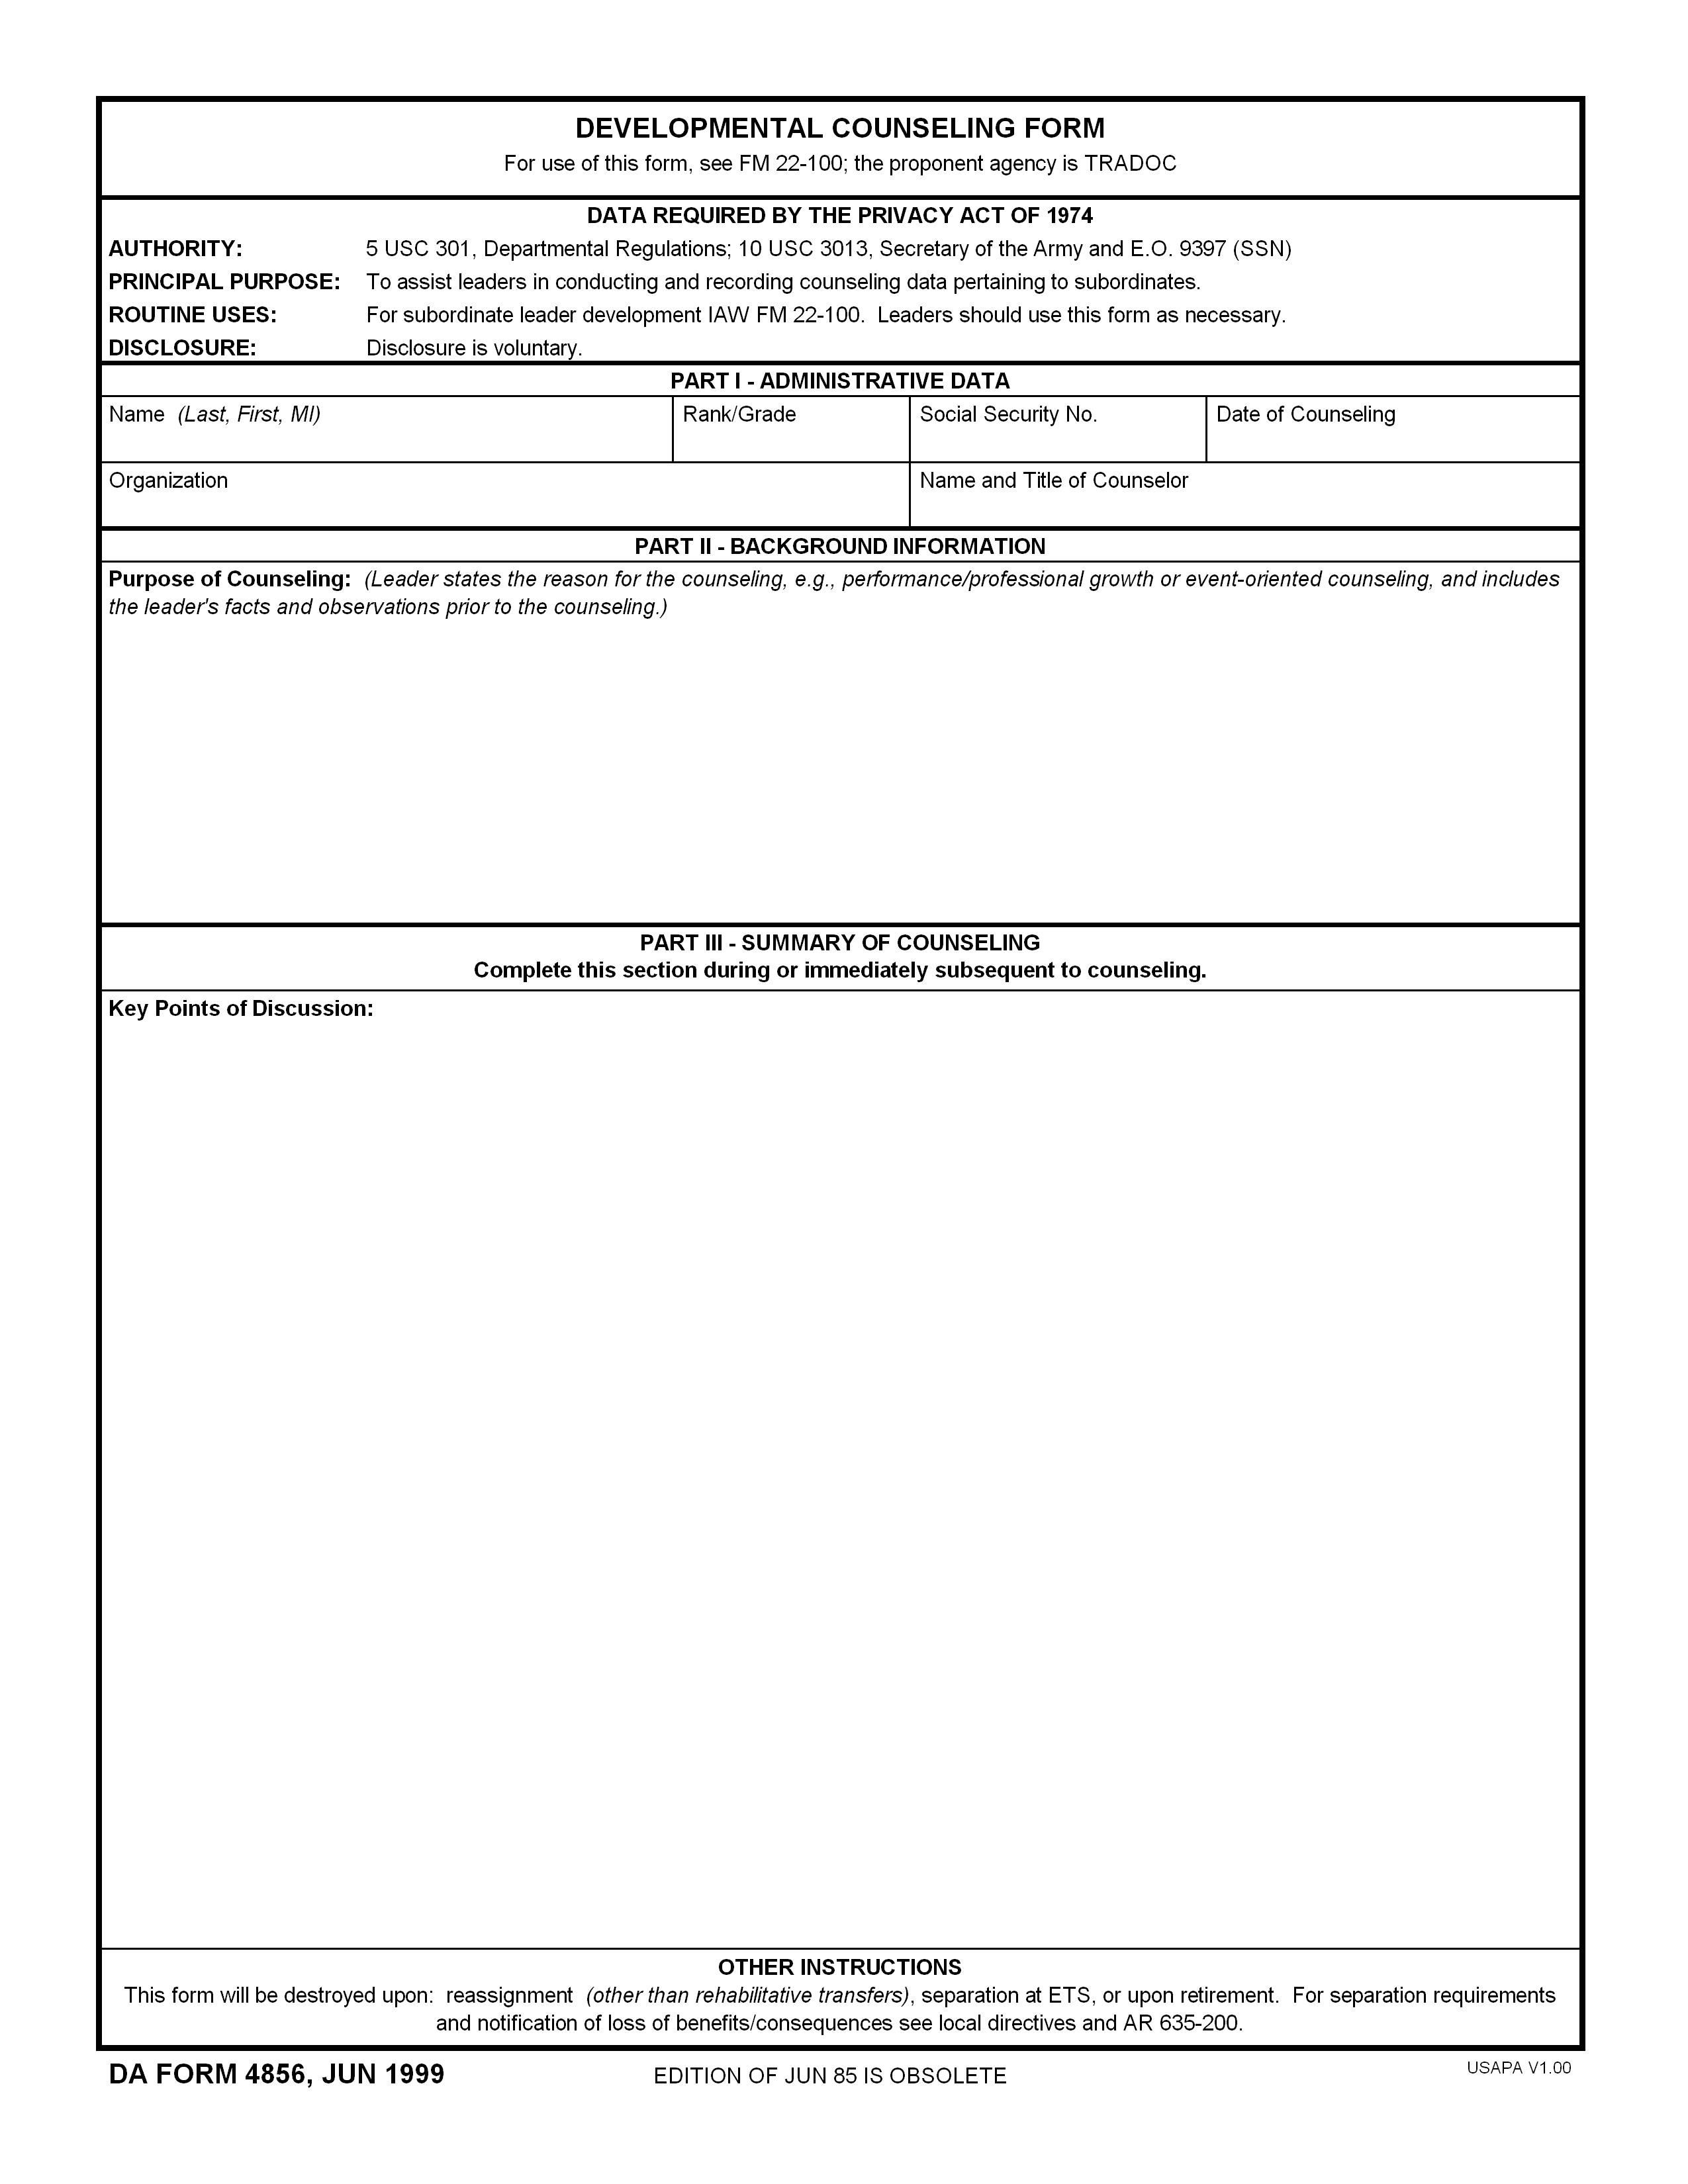

Company Commander Policy Letter #12 Army Substance Abuse Program
Enrollment into the ASAP
Drug and Alcohol Awareness

I am counseling you on events that have occurred within the company that have jeopardized the unit’s ability to perform its mission as a company. During our last BN 100% urinalysis testing, it came to my attention that there may be illegal drug use within the Plt. Several Soldiers from the Company came back positive for drug use. The statement below explains the Army policy on drug use. Also, see the Company Commander's policy Letter #12 Army Substance Abuse Program.

a. Army Regulation 600-85 prohibits the use, possession, and sale of illegal substances and dangerous drugs. Although alcoholic beverages are generally legal, the use of alcoholic beverages to the extent that they interfere with a person’s normal daily living or job performance is considered abuse. Abuse of alcohol and the use, possession, and/or sale of illegal and dangerous drugs will not be tolerated within this command.

b. A variety of methods are available to supervisors for identifying personnel with an alcohol or drug abuse problem. Individuals who recognize that they have a problem are encouraged to refer themselves for treatment under the Army’s Limited Use Policy. Soldiers who appear on the MP blotter report for incidents involving alcohol and drugs will be referred to the Community Counseling Center for evaluation. Command referrals will also be made if an individual is suspected of having an alcohol or drug problem.

c. Command directed urinalysis testing is another tool that may be used in the identification process. Urinalysis testing will be conducted at the Company on a monthly basis. Approximately 25% of the Companies personnel will be selected randomly by the Alcohol Drug Coordinator. Those selected will be notified the day of the test and will report to the Company for testing.

d. Early detection and referral are important in the rehabilitation of individuals involved in alcohol or drug abuse. If a Soldier is identified, their supervisor will use all available resources and make coordination with the appropriate agencies to provide confidential rehabilitation services.

I am counseling you for the conduct above. If this conduct continues, action may be initiated to separate you from the Army under AR 635-200, Chapter 13. If you are involuntarily separated, you could receive an Honorable discharge, a General (Under Honorable Conditions) discharge, or an Under Other Than Honorable discharge. An Honorable discharge may be awarded under any provision. A General discharge may be awarded for separation under Chapter 5, Chapter 9, Chapter 13, and Chapter 14. An Under Other Than Honorable discharge may be awarded for separation under Chapter 14. If you receive an Honorable discharge, you will be qualified for most benefits resulting from military service. An involuntary Honorable discharge, however, will disqualify you from reenlistment for a period of time and may disqualify you from receiving transitional benefits (e.g. commissary, housing, health benefits) and the Montgomery G.I. Bill. If you receive an Other Than Honorable Conditions discharge, you will be ineligible for reenlistment and for most benefits, including payment for accrued leave, transportation of dependents and household goods to home, transitional benefits, and the Montgomery G.I. Bill. You may also face difficulty in obtaining civilian employment, as employees have a low regard for General and Under than Honorable Conditions discharges. Although there are agencies to which you may apply to have the character of your discharge changed, it is unlikely that any such application will be successful.

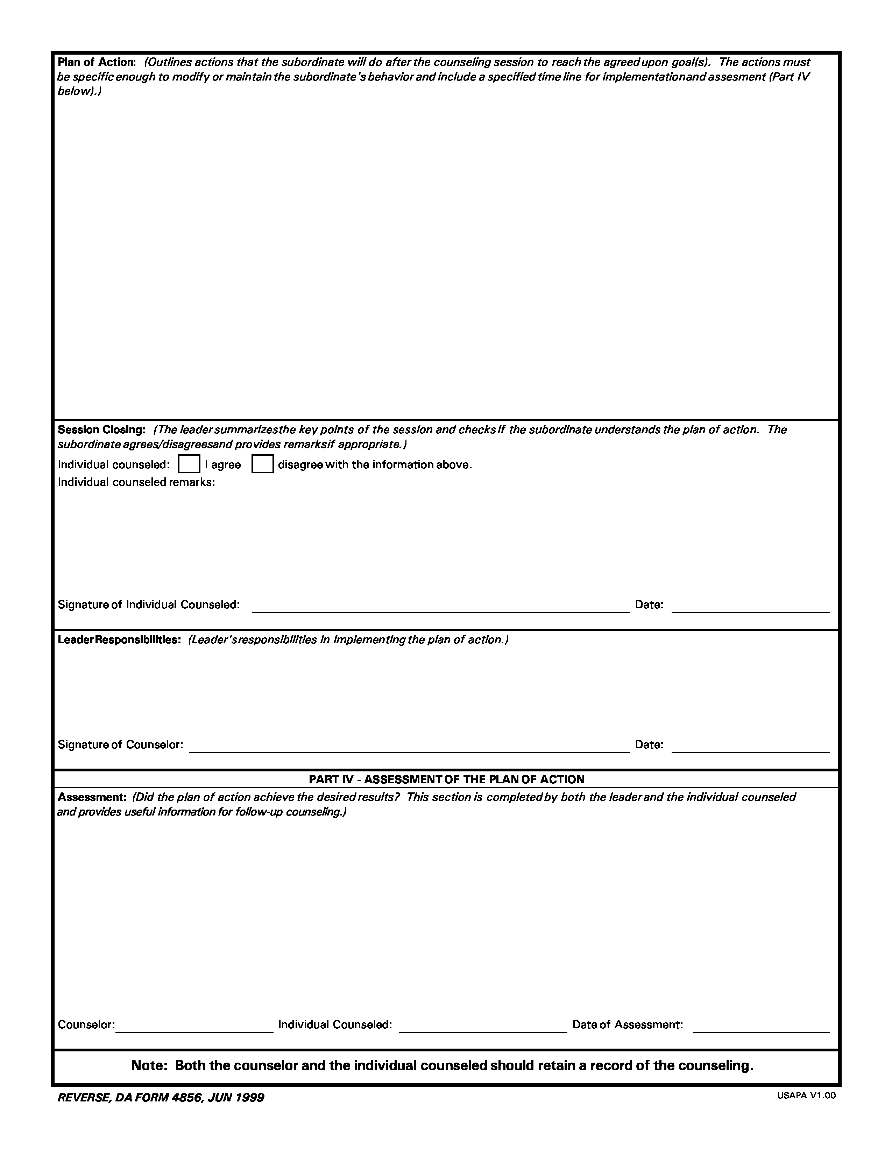
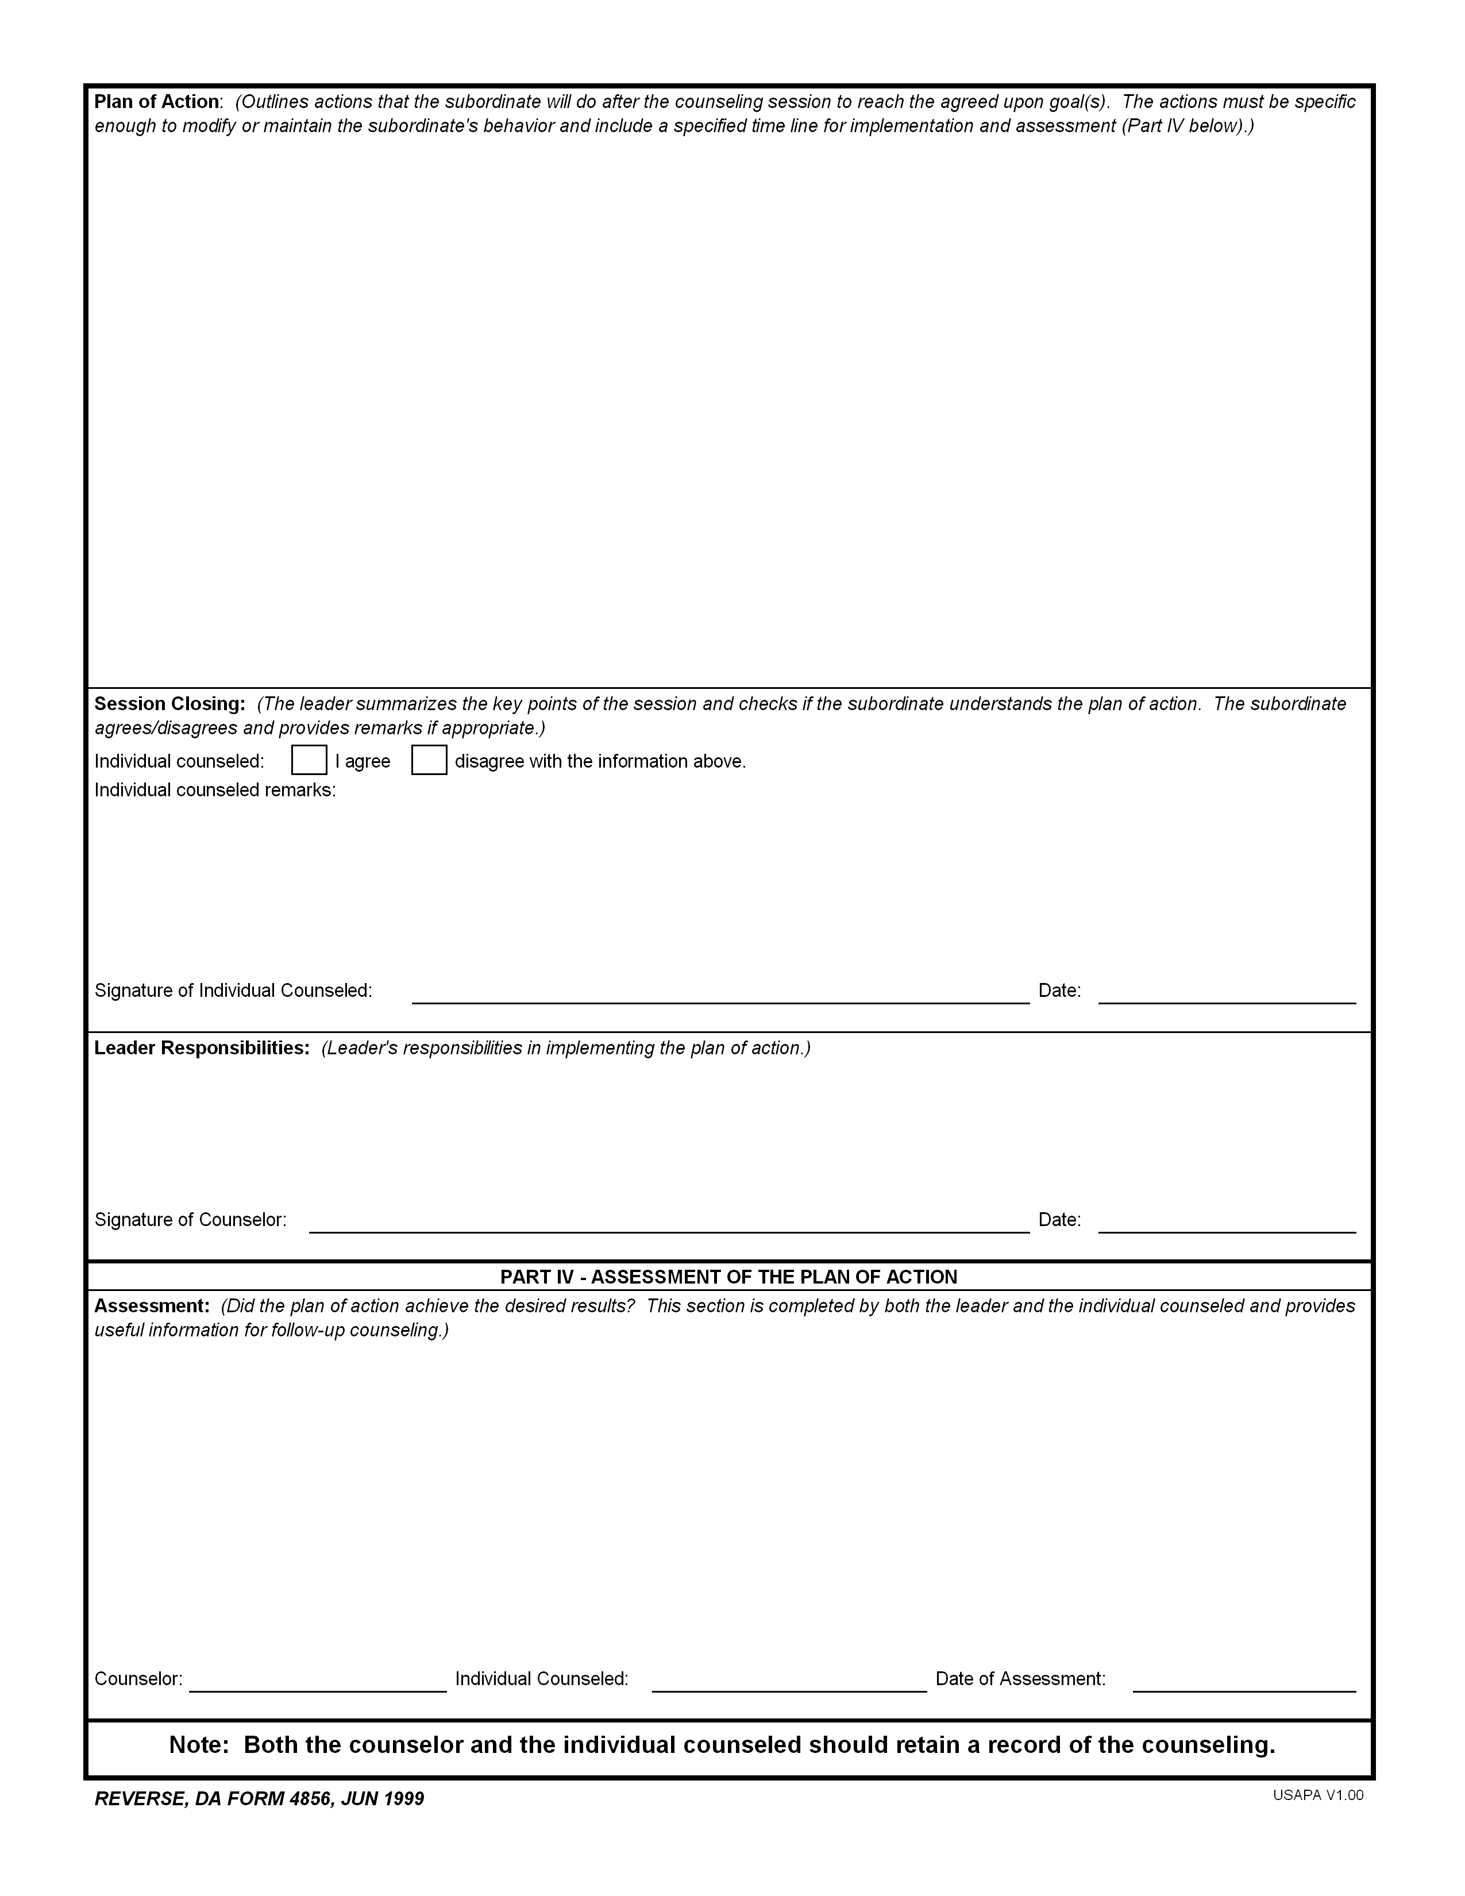
I am recommending the following actions to the Chain of Command: If any violations of the policies described above occur, I will request UCMJ against you.
- In addition, if your performance continues to be substandard and does not improve, I will consider recommending you for punishment under the UCMJ and/or possible chapter action.
- If you’re identified I will use all available resources and make coordination with the appropriate agencies to provide confidential rehabilitation.
- Soldiers who appear on the MP blotter report for incidents involving alcohol and drugs will be referred to the Community Counseling Center for evaluation. Command referrals will also be made if an individual is suspected of having an alcohol or drug problem.

- To ensure all members of the Plt understand their obligation to ensure a “Drug Free” environment.
- If a Soldier is identified, their supervisor will use all available resources and make coordination with the appropriate agencies to provide confidential rehabilitation.
- Soldiers suspected of or exhibiting signs of intoxication will be subject to a field sobriety test administered by the Military Police.

